Form 5
THE PATENT ACT 1970 (39 of 1970) &
The Patents Rules, 2003 DECLARATION AS TO INVENTORSHIP
[see section 10 and rule 13(6)]
- NAME OF APPLICANT |  | Gujarat Council on Science and Technology (GUJCOST), an Indian entity, having address at Block B, 7th Floor, M. S. Building, Nr. Pathikashram, Sector 11, Gandhinagar, Gujarat – 382011, India  Indian Institute Of Technology, Bhubaneswar, an Indian entity, having address at Argul (Jatni), Khordha, Odisha, 752050
Hereby declare that the true and first inventors of the invention disclosed in the complete specification
filed are
- INVENTOR
Name |  |  | Nationality | Address
Dr. Yogesh G. Bhumkar |  |  | INDIAN | Indian Institute Of Technology, Bhubaneswar, Argul (Jatni), Khordha, Odisha, 752050
Prabhuparth Choudhar |  |  | INDIAN | Indian Institute Of Technology, Bhubaneswar, Argul (Jatni), Khordha, Odisha, 752050
Palash Jain |  |  | INDIAN | Indian Institute Of Technology, Bhubaneswar, Argul (Jatni), Khordha, Odisha, 752050
Mihir V. Khunti |  |  | INDIAN | Indian Institute Of Technology, Bhubaneswar, Argul (Jatni), Khordha, Odisha, 752050
Divyang Vegda |  |  | INDIAN | Indian Institute Of Technology, Bhubaneswar, Argul (Jatni), Khordha, Odisha, 752050
Signature and Name of the signatory: | Signature:-  Name of the Signatory: Dr. Narottam Sahoo  Advisor and Member Secretary  Gujarat Council on Science and Technology  Dept. of Science and Technology, GoG.  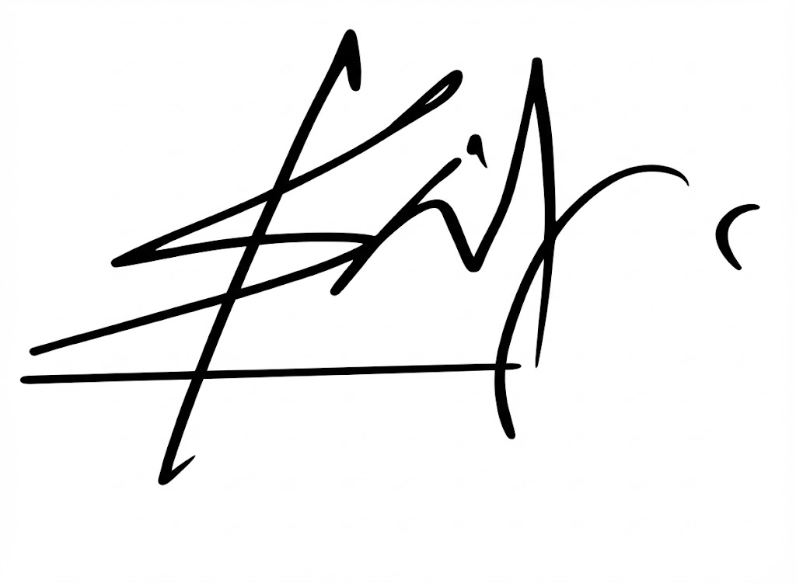  Signature:-  Name of the Signatory: Prof. Shantanu Pal  Dean, Under Graduate Programs  IIT Bhubaneswar.  Date: 16th February 2026
- DECLARATION TO BE GIVEN WHEN THE APPLICATION IN INDIA IS FILED BY THE APPLICANT (S) IN THE CONVENTION COUNTRY: -

We the applicant(s) in the convention country hereby declare that our right to apply for a patent in India is by way of assignment from the true and first inventor(s).
Dated this day of 20
Signature:-
Name of the Signatory:-
4. STATEMENT (to be signed by the additional inventor(s) not mentioned in the application form)
I/We assent to the invention referred to in the above declaration, being included in the complete specification filed I pursuance of the stated application.
Dated this day of 20
Signature of the additional inventor(s):- Name:-
To,
The Controller of Patent
The Patent Office, at MUMBAI

